MINUTES OF THE PARISH COUNCIL MEETING HELD IN THE VILLAGE HALL,
7.30pm 15th May 2023.

PRESENT - Mr P. Mortimer, Mr P. Schwier, Mrs C Pryce, Mr C Osborne, Mr B Lee-Harwood, Mr P Smith

Clerk- Mrs L Duckett

No members of the public were present.

1.ELECTION OF CHAIR 2023/2024
Mr P Mortimer was nominated by Mr P Schwier, seconded by Mrs C Pryce. The Parish Council were unanimous in electing Mr P Mortimer as Chair

2.APOLOGIES FOR ABSENCE
Councillor P Gould (SCC), Councillor L Hadingham (MSDC), Mrs D Fowler
and DECLARATIONS OF ACCEPTANCE/INTEREST
All Parish Councillors completed the declaration of acceptance/interest forms, which were then signed by the Clerk/Responsible officer.

3.APPOINTMENT OF OFFICERS
Vice Chair – Mr P Schwier (nominated by Mr P Mortimer, seconded by Mr P Smith)
Responsible Officer – Mrs L Duckett
External auditor – Mrs W Abbott

4. TO APPROVE THE MINUTES FROM THE MEETING HELD 13th MARCH 2023.
The minutes were agreed and approved.

5. MATTERS ARISING FROM THE MINUTES –
Parking has improved outside of Field Close, with less parking on the pavement, but it has not been eradicated completely. The situation will continue to be monitored. The Coronation tree has been planted, and tree guard and plaque ordered. Both will be installed in the next couple of weeks.
Following the resignation of Mr T Godbold and Mr P Twiss, two vacancies will be advertised. Letters of thanks will be issued.

6. REPORT FROM DISTRICT COUNCILLOR HADINGHAM
No report was provided this month due to the District Council election

7. REPORT FROM COUNTY COUNCILLOR GOULD (as provided)
Cllr Gould’s report can be found at the end of these minutes.
There were no questions on the report.

8. MATTERS RAISED BY MEMBERS OF THE PUBLIC
Concern had been raised over the continued issues experienced by residents of Field Close. The Parish Council has no input or influence on these matters, but the concerns have been passed on to Cllr Hadingham.
The Parish Council have been asked if they could increase the donation made annually towards the upkeep of the churchyard. After some debate it was agreed that the donation would be increased to £200, but that it must be used for the churchyard or the Parish Council would in breach of the law when making such donations.
Previously concern has been raised over the current home school transport rules, which has resulted in the school bus being under utilised and parents having to drive their children to school. Following a chance meeting between the Chair and Rachel Hood, Cabinet member for education at Suffolk County Council, an email has been compiled based on the current concerns of parents and forwarded at her request. No response has been received to date.

9. FINANCE
i)To approve any payments due.
Approved between meetings via email/site meeting –
Mr R Hewitt – grass cutting £150.00
Designer Metal (Suffolk) Ltd – tree guard £150.00
Clerk’s salary £487.88
HMRC Tax £9.40

Payments approved at the meeting
BHIB Annual insurance £362.00
Metfield Village Hall hire (April 22 – Mar 23) £85.00
MSDC Bin emptying charges £198.86
Mr N Riseborough – grass cutting St Johns Meadow £468.00
Playdale Ltd. – balance due on play equipment £5,383.44
L Duckett – Expenses (Print cartridges, paper, plaque, gratuity) £39.50

ii)To approve accounting statement for the 2022/23
No changes had occurred following the review of the accounts at the last meeting.
The accounts were approved. Full details of the accounts statement will be made available via the MetfieldSuffolk.com website under Parish Council/ Finance.

iii)To approve and sign the Annual Governance Return for 2023
The Annual Governance return has been completed and an external audit carried out by Mrs W Abbott. It was approved and signed and will be submitted according to requirements and made available to view via the MetfieldSuffolk.com website under Parish Council/ Finance. The public rights statement will also be posted in the same place and on the Parish Notice board.

10.PLANNING – TO REVIEW ANY CURRENT PLANNING APPLICATIONS
Two planning applications were received between meetings:
DC23/01228 The Gables, Fressingfield Road – application for a single storey extension to the rear of the property.
No objections were raised to the application – awaiting decision.
DC23/01823 The Old Forge, The Street – application to remove old overgrown apple tree in a conservation area
No objections were raised to the application – permission has been granted.

Resident concerns have been raised over noise coming from the Wakelyns area, and the number of caravans visible from the footpath. The Clerk will seek advice from the planning office.

11. CEMETERY EXPANSION
The hedge planted at the beginning of the year looks good. The Clerk is monitoring growth and has replaced the few plants that have failed. Two trees, both Mountain Ash, do not appear to have survived. The biodiversity officer at MSDC has promised to provide some damson trees in the autumn, so they will be used to replace anything if necessary. Bark is still to be mulched at the base of the hedge, but as it has been so wet this hasn’t caused any issues.
The Edens have requested that a fence be erected around the perimeter of the expansion area – this will be investigated at the next meeting.
Paths now need to be cut through the new area, and the gravel driveway at the entrance needs spraying again.
Mr Schwier volunteered to investigate a seating supplier. 3 wooden benches and a tree seat will be purchased if affordable.

12. MATTER RAISED BY COUNCILLORS
Discussions were had around the possibility of purchasing a secondhand speed indicator from Beccles Town Council, but it was decided that it wasn’t suitable. The Clerk had received an email regarding a campaign to adopt a 20mph speed limit throughout Suffolk villages – it was agreed that the Council would review the content and let the Clerk know if they were happy to sign up to the agreement. The Clerk would also sign up for one of the webinars to gain more information.

A large pothole had appeared in the centre of Low Road, just beyond the Crooked Cottage – the Clerk will report.

The Chair requested the meeting date for September to be moved to 25th from the 11th. All were happy for this to be changed.

13.CORRESPONDENCE
An email had been received from Mrs C Williams, thanking the Parish Council for leaving the “wild” strip on St John’s Meadow.

The meeting closed at 8.55 pm.

DATE OF NEXT PARISH COUNCIL MEETING - Monday 10th July 2023

SCC Report, as supplied by Councillor Gould

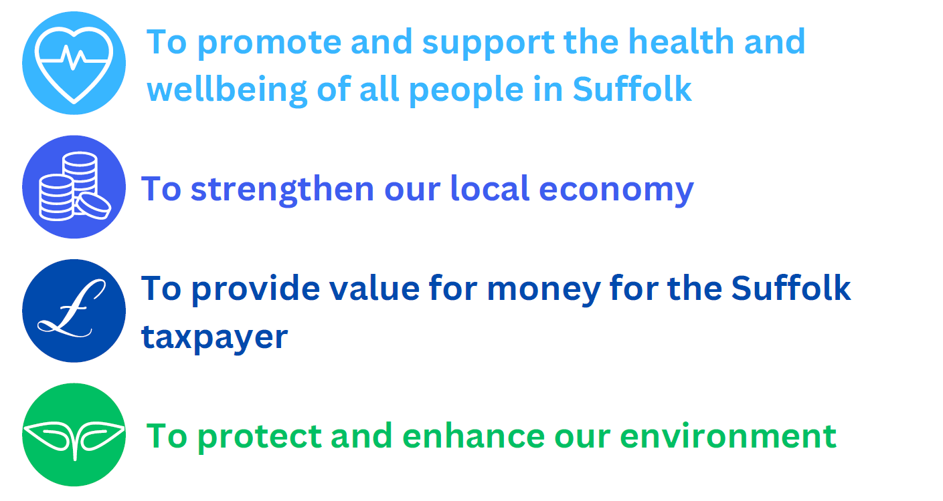
Hoxne and Eye Division
April 2023 Town and Parish Newsletter

For more information on all stories visit:
Suffolk County Council | Conservative Group (suffolkconservatives.org.uk)

Princes Street’s police and fire station receives royal seal of approval
Suffolk’s largest joint emergency services hub was officially opened by HRH The Princess Royal today (Tuesday, 28 March), with the new facility in Ipswich marking the latest milestone in a highly successful collaborative scheme.
The Princess Royal was joined by local dignitaries, including Suffolk’s High Sheriff, the county’s Police and Crime Commissioner, Deputy Chief Constable and Chief Fire Officer, councillors from Suffolk County Council and the Mayor of Ipswich for the grand opening of the shared site earlier this afternoon (Tuesday, 28 March).
During her time at the new station, HRH The Princess Royal spoke to staff from Suffolk Constabulary and Suffolk Fire and Rescue Service who have already begun to benefit from using the state-of-the-art facility.
Demonstrations of some of the fire service’s work, including water and animal rescues, also formed part of the visit, along with a tour of the building, which has undergone extensive renovations since work started on the project in December 2020.
Situated in the heart of Suffolk’s county town, the facility will help maintain public safety, ensure a swift response to incidents, and promote partnership working.
Councillor Andrew Reid, Suffolk County Council’s Cabinet Member for Public Health and Public Protection, commented:
“It was an honour to welcome HRH, The Princess Royal, for the opening of the largest combined police and fire facility in Suffolk today, cementing the station’s status as the jewel in our county’s crown and celebrating the latest in a long line of hugely successful collaborations with our emergency services partners.

He added: “We have already started to see the vast benefits of this shared site, which enables the efficient and cost-effective delivery of response activity in an environmentally responsible manner, ensuring continued value for money for our residents whilst supporting our council’s net-zero ambitions.
“I would like to thank everyone involved in delivering the new building; their attention to detail has resulted in a modern, fit-for-purpose station we can all be proud of, not just locally but on a national level, with Suffolk’s integrated blue light hub scheme heralded as an exemplar by central government.”
Tim Passmore, Suffolk’s Police and Crime Commissioner, added:
“Our county was very privileged to welcome the Princess Royal for the official opening of the new joint Police and Fire Station in the centre of Ipswich.

He added: “Our joint estates programme is one of the most important and significant examples of joint working nationally and is an excellent example of what can be achieved by pooling resources and working together. A great result for Suffolk.”
The multi-million-pound project has also boosted the local economy, following the use of Suffolk-based companies Concertus and RG Carter for the station’s design and construction.

99% of pupils receive a preferred primary school place on National Offer Day
99.18% of children were offered a place on National Offer Day at one of their three preferred primary schools and 95.78% were offered a place at their first preference school.

Suffolk County Council received 7,056 applications from parents and carers indicating which primary school they would prefer their child to join in September 2023.
Families who applied online can log on to the Admissions Portal from today to see the school their child has been offered. They will also receive an email to confirm this offer. Letters will be sent to parents who made a paper application by second-class post today (17 April 2023).
Allan Cadzow, Director of Children’s, and Young People Services for Suffolk County Council said:
“It is great news that the majority of families have once again been offered a place at one of their preferred schools, especially with so many being offered a place at their first preference school.”

“We appreciate that not all families may have received a place at their preferred school. If a parents’ preference for a Suffolk school is refused, we will automatically add their child’s name to the waiting list for that school. Parents and carers will also be advised about how to lodge an appeal should they wish to do so.”
Once school places have been confirmed, parents need to consider how their child will get to and from school. If their child is eligible for Suffolk County Council funded school travel, they will receive an email by 12 May 2023 with details of how to opt in.
Any parents or carers with a child born between 1 September 2018 and 31 August 2019 who have not yet applied for a school place should make an application immediately.
Information on how to make an application can be found on the School admission pages or by contacting Suffolk County Council on 0345 600 0981.

Suffolk to mark Dementia Action Week with event
A drop-in event for people with dementia, their families, and carers, will be held next month at Trinity Park in Ipswich.

Representatives from more than 34 care organisations across Suffolk will host stalls at the event, which will showcase the wide range of information, advice, and support available to people living with dementia and their carers, to help them to get the right support from the right providers, at the right time.
Running alongside the marketplace will be keynote sessions on a range of topics including how to live well with dementia from those with lived experience, memory assessment and the importance of a timely diagnosis.
There will also be the opportunity for people with the condition and their carers to hear about the development of a countywide dementia strategy for Suffolk, and provide feedback on their experiences, needs and priorities for support.
The event, which is being facilitated by the Suffolk Dementia Action Partnership and Care Development East, will be held on Tuesday 16 May from 10 am, during Dementia Action Week.
Dr Ros Tandy, Mental Health Clinical Lead for the NHS Suffolk & Northeast Essex Integrated Care Board, said:
“Dementia and Alzheimer’s Disease are the leading causes of death in England and there are around 15,000 people in Suffolk living with the condition, so it is essential that those who care for them have a full picture of the support available to them.
“I am really looking forward to attending this event and hearing from members of our community about their experiences of our local dementia services. It’s great that there will be activities for people with dementia to take part in at the event so their carers are able to look around and learn more about what support is available from all the different stalls.”
Georgia Chimbani, Director of Adult Services at Suffolk County Council said:
“I hope that this event will give people the opportunity to explore the wide range of dementia support which is available in Suffolk. I am also pleased that Suffolk Dementia Action Partnership, with support from Care Development East, intend to follow this event with smaller locality-based roadshows across Suffolk, to help as many people as possible access this information.”
The event will feature a designated 'Quiet Room' with activities for people with dementia to allow their carers time to look at the stalls and attend the presentations.
Tea and coffee will be available throughout the day, and other drinks and food can be purchased from the onsite bar.
To book your ticket please visit the Eventbrite website.

Huge crane in place as major steel sections arrive for Gull Wing bridge
The Gull Wing bridge is taking shape as more steel sections arrive in Lowestoft.

One of the biggest cranes of its kind in the world has been set up in Lowestoft for the arrival of the first steel sections for the southern side of the Gull Wing bridge.
The huge crane was in place for when South Approach Viaduct (SAV) sections 1 and 3 arrived at the construction site on Lake Lothing on the evening of Sunday, April 23 on a barge from Ghent in Belgium.
Leading building and civil engineering contractor Farrans are constructing the bridge for Suffolk County Council.
Fabricated by Victor Buyck Steel Construction, SAV1 is approximately 35 metres long and SAV3 is 41m long.
SAV1 will weigh 105 tonnes and SAV3 weighed 213 tonnes.
The huge crane has been erected on the southern side of Lake Lothing to move the sections.
The Terex Demag CC8800-1 has a maximum lifting capacity of 1,600 tonnes and is one of the largest crawler cranes in the world.
It was brought into Lowestoft from Copenhagen and off-loaded by the crane used to unload the northern approach sections that arrived from the Netherlands last month.
Assembly and testing of the crane took approximately 10 days.
SAV3 will be offloaded first and placed on a temporary base. SAV1 will then be offloaded directly into position on the Southern Approach Abutment and Pier 1.
The barge will then sail back to Ghent to collect SAV2 and SAV4. SAV2 is 30m long and weighs 90 tonnes, while SAV4 is 45m long and 381 tonnes.
After the return crossing - due to take place in the coming days subject to weather conditions - the barge will be moored up and SAV2 offloaded directly onto Piers 1 and 2.
SAV3 will then be picked up from the temporary base and placed onto Piers 2 and 3. Finally, SAV4 will be lifted directly from the barge onto Piers 3 and 4.
Once in place, a site weld and bolted splices will secure the four sections to each other. A concrete pour will then set the viaduct in its final position.
Simon Bretherton, Suffolk County Council Project Director, said:
“The arrival of these next sections will see the structure take shape for the first time on both sides of Lake Lothing.

“This is another major step forward and we continue to make good progress on building what will be an iconic structure providing a new era for jobs, businesses and connectivity for the town of Lowestoft and the wider area.”
Neil Rogers, Project Director for Farrans Construction, said:
“This week’s arrival of four large sections of the bridge is an important and busy time for our site team.

“A lot of planning takes place in advance of the sections being transported into Lowestoft and, once here, we will be beginning the process of lifting these elements into position almost immediately.

“To have one of the largest cranes in the world on site for this project is a fantastic learning opportunity for our apprentices, graduates and placements.”

