MINUTES OF THE PARISH COUNCIL MEETING HELD IN THE VILLAGE HALL,
7.30pm 13th May 2024.

PRESENT - Mr P. Mortimer, Mr P. Schwier, Mrs C Pryce, Mr C Osborne, Mr B Lee-Harwood, Mr P Smith, Mrs D Fowler, Mr D Hall, Mr J Gadsdon

Clerk- Mrs L Duckett

No members of the public were present.

1.ELECTION OF CHAIR 2024/2025
Mr P Mortimer was nominated by Mrs D Fowler, seconded by Mr P Schwier. The Parish Council were unanimous in electing Mr P Mortimer as Chair

2.APOLOGIES FOR ABSENCE
Councillor L Hadingham (MSDC)
and DECLARATIONS OF ACCEPTANCE/INTEREST
There were no changes to the declaration of acceptance/interest forms which were submitted last year.

3.APPOINTMENT OF OFFICERS
Vice Chair – Mr P Schwier (nominated by Mr P Mortimer, seconded by Mr P Smith)
Responsible Officer – Mrs L Duckett
External auditor – Mrs W Abbott

4. TO APPROVE THE MINUTES FROM THE MEETINGS HELD 11th MARCH and 23rd April 2024.
The minutes were agreed and approved.

5. MATTERS ARISING FROM THE MINUTES –
The fence adjacent to the play area has now been replaced. Signs indicating no ball games allowed in the area have been purchased and put up.
No further activity has been observed at Withersdale Hall Farm. It is not known if the site is now cleared.
The Clerk has checked with the Village Hall committee chair and the defibrillator is formally registered. The pads will need replacement this year. They have asked for financial assistance – the Clerk is still awaiting further information on the exact amount required.
The grass cutting vacancy has been filled – also see under item 12, Matters raised by Councillors below.

6. REPORT FROM DISTRICT COUNCILLOR HADINGHAM (as provided)
The MSDC monthly report was circulated prior to the meeting and can be found at the end of these minutes. No questions were raised.

7. REPORT FROM SUFFOLK COUNTY COUNCIL
No report was received from Suffolk County Council this month.

8. MATTERS RAISED BY MEMBERS OF THE PUBLIC
No matters were raised by the Public

9. FINANCE
i)To approve any payments due.
CC Annual insurance £472.11
The Clerk had received 3 quotes for insurance all within £25 of one another. Although approval was received to pay the full amount the Clerk will endeavour to get some reduction on the premium before paying.
L Duckett – Expenses (Plaques for cemetery seating, gratuity) £32.96
Prior approval for the purchase of gravel for the cemetery (Approx £500)
(also see under item 11 below)

ii)To approve accounting statement for the 2023/24
No changes had occurred following the review of the accounts at the last meeting.
The accounts were approved. Full details of the accounts statement will be made available via the MetfieldSuffolk.com website under Parish Council/ Finance.

iii)To approve and sign the Annual Governance Return for 2024
The Annual Governance return has been completed and an external audit carried out by Mrs W Abbott. It was approved and signed and will be submitted according to requirements and made available to view via the MetfieldSuffolk.com website under Parish Council/ Finance. The public rights statement will also be posted in the same place and on the Parish Notice board.

10.PLANNING – TO REVIEW ANY CURRENT PLANNING APPLICATIONS
DC/24/00579 Retention of change of use of 2no existing farm buildings to a commercial use under Class B8 of the Use Classes Order 1987 (as amended). Vale Farm, The Common, Metfield
Permission for the above has been refused. It was thought that the site was still operating, but enforcement is involved.
DC/24/01730 Proposal: Erection of a single storey cart lodge with workshop.
Location: The Dairy Lodge, Fressingfield Road, Metfield, Harleston Suffolk IP20 0LL
This is a re-submission of DC23/04355 due to an issue with the ecological report. Nothing has been changed so the Parish Council had no objection to the application. Comments were submitted between meetings.

11. D-DAY AND OFFICIAL CEMETERY EXPANSION OPENING
The Clerk distributed flyers between the Councillors for distribution to residents, inviting all to the official opening of the new cemetery area prior to the lighting of the beacon in commemoration of the 80th anniversary of D-Day on 6th June. The event will require a full risk assessment prior to the lighting of the beacon.
The Clerk has also met with Christine Brennan to confirm wording for the plaques to be mounted on the seating purchased with the donation from the proceeds of Mrs Brennan’s book. Mrs Brennan has agreed to officially open the area.
In preparation for the opening, it was approved that additional gravel will be purchased for the driveway (approx. £500), Mr Mortimer will organise. The benches will be positioned by Mr Mortimer and Mr Schwier. All offered additional assistance if required. Hugo Pryce will be asked if he can mow some paths through the long grass to the seating areas.

12. MATTER RAISED BY COUNCILLORS
The Parish Council discussed the standard of grass cutting of the cemetery and play area following the appointment of a new grass cutter, with the majority having inspected both areas prior to the meeting. They were disappointed in what they saw. The grass is still considered too long and the strimming inconsistent, but it was the amount of dead grass lying that caused most concern. Whilst they appreciate it will take some time to get the grass back to a reasonable state, they voiced concern over the need to have the grass “knocked back” again following a delay in the first cut being made. There were mitigating circumstances of a broken mower, which were considered, but the mowing currently needs frequent and regular attention. There was also concern over whether the equipment used is up to the job.
The cemetery will be officially opened on the 6th June – the councillors agreed that they should give Mr Kingsley until then to get the grass back to being neat and tidy. They have requested that he remove the dead material, especially from around the flat cremation memorials by the seat which were completely buried.
Mrs Fowler is continuing to inspect the play equipment on a regular basis. It was agreed that this should be formally minute-ed going forward, but she would raise concern between meetings if needed. A bolt requiring tightening on the swing has been addressed. The bark under the swings will be inspected to see if it just needs raking back into position, or more is needed.

13.CORRESPONDENCE
The Clerk had circulated correspondence suggesting the Parish Council consider setting up their own web domain as a .gov.uk website. There would be an initial cost of £100 to do this, it was not clear what the ongoing costs would be. All agreed that it was not currently in the Parish Council’s interest to do so but would review the situation if more information was issued by the government.
The Clerk had also circulated the following guidelines and policies prior to the meeting for review. All were considered, reviewed and adopted for a further year. Copies can be found on the MetfieldSuffolk.com website.

Financial regulations
Metfield Parish Councillor objectives
Metfield Parish Councillor standing orders.
Code of Conduct
Safeguarding policy
Equality, Diversity, and Inclusion policy
Health and Safety Policy

The meeting closed at 8.45 pm.

DATE OF NEXT PARISH COUNCIL MEETING - Monday 8th July 2024

MSDC Report – as provided.

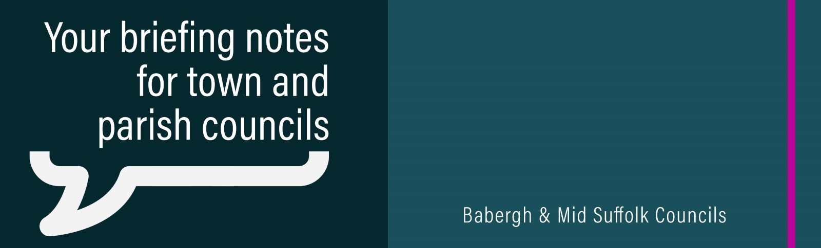

May 2024

NB: Pre-election restrictions have been in place for this period.

Upcoming elections and referendums
The next election within our district is on Thursday 2 May. More details about the election for the Police and Crime Commissioner, as well as all other elections and referendums being held on the same day, can be found on the council’s website.

Candidates announced for by-election in the Chilton (Stowmarket) ward
The Mid Suffolk District Council by-election will take place on Thursday 2 May.

Boosting green jobs and supporting businesses in the East of England
Two new funds, with a combined value of up to £800,000, are now available to businesses within our districts, courtesy of Freeport East.

